**Table of Contents**

1 Objective of This Experiment 1

2 The 1phase Full-Bridge Inverter 1

2.1 The Square-Wave Switching 1

2.1.1 The harmonic spectrum of the output voltage 2

2.2 The PWM Switching 2

2.2.1 The waveforms and the harmonic spectrum of the output voltage 3

3 The 3phase 6-pulse inverter 4

3.1 The Square-Wave Switching with 180o conduction 5

3.1.1 The waveforms and the harmonic spectrum of the output voltage 5

4 Conclusions 6

**List of Figures**

Figure 1:- The figure shows the connection diagram of the 1phase full-bridge inverter 1

Figure 2:- The figure shows the harmonics of the output voltage 2

Figure 3:- The figure shows the waveforms of the input/output voltage and current. 3

Figure 4:- The figure shows the harmonics of the output voltage 4

Figure 5:- The figure shows the connection diagram of the 3phase 6-pulse inverter 4

Figure 6:- The figure shows the waveforms of the input/output voltage and current. 5

Figure 7:- The figure shows the harmonics of the output voltage 6

# 1 Objective of This Experiment

The main objectives of this experiment are to build and examine DC-AC single-level conversion circuits as single-stages switched converters, as well as to investigate the operational properties of the of 1φ and 3φ inverters under different switching methods. This laboratory session also aims to investigate the different spectra of inverters’ output voltages and impacts of the switching strategies on quality and quantity of output voltages. For this experiment we would need; DC variable voltage supply, resistive load and a 3φ induction motor, IGBT chopper/Inverter module, connection leads (different lengths), the labvolt data acquisition module (DAM), the DC-AC converter firing angle controller.

# 2 The 1phase Full-Bridge Inverter

The figure below shows the connection diagram of the 1phase full-bridge inverter; the 1phase full-bridge inverter was constructed using the labvolt IGBT chopper/inverter module.

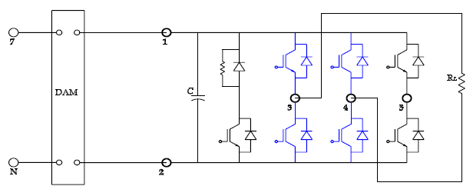

Figure 1:- The figure shows the connection diagram of the 1phase full-bridge inverter

## 2.1 The Square-Wave Switching

The switching pulses for the used IGBT switch are generated by the DC-AC converter firing angle controller for square-wave switching. This experiment was performed using a resistive load of 400ohms and a supply voltage of 60V. The data acquisition module (DAM) was used to observe and record; output voltage, output current, input power, and output power; these values are 59.43V, 0.149A, 8.795W, and 8.0806W respectively. We observed and recorded the harmonic spectrum of the output voltage (Vo) with THDV = 43.5%.

### 2.1.1 The harmonic spectrum of the output voltage

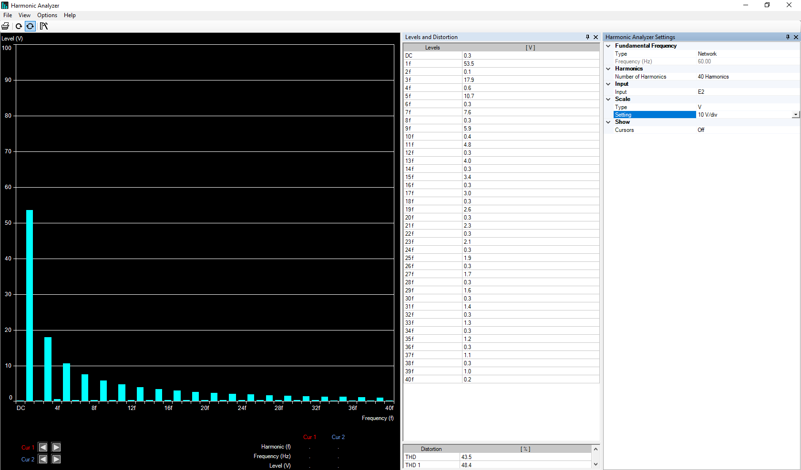

Figure 2:- The figure shows the harmonics of the output voltage

## 2.2 The PWM Switching

This experiment was performed using a resistive load of 400ohms and a supply voltage of 60V. The data acquisition module (DAM) was used to observe and record; output voltage, output current, input power, and output power; these values are 38.15V, 0.096A, 3.54W, and 3.51W respectively. The DAM software was used to generate PWM with a switching frequency of 8kHz, and the DC bus voltage variable to 80%. We observed and recorded the waveforms and harmonic spectrum of the output voltage (Vo) but in this case we should calculate the THD according to our results. If we calculate the THDV according to the THD formula and the results in Figure 4, the THD would be as follow:

 

So, the THD for PWM switching is 0.921% which is significantly lower than square wave switching.

### 2.2.1 The waveforms and the harmonic spectrum of the output voltage

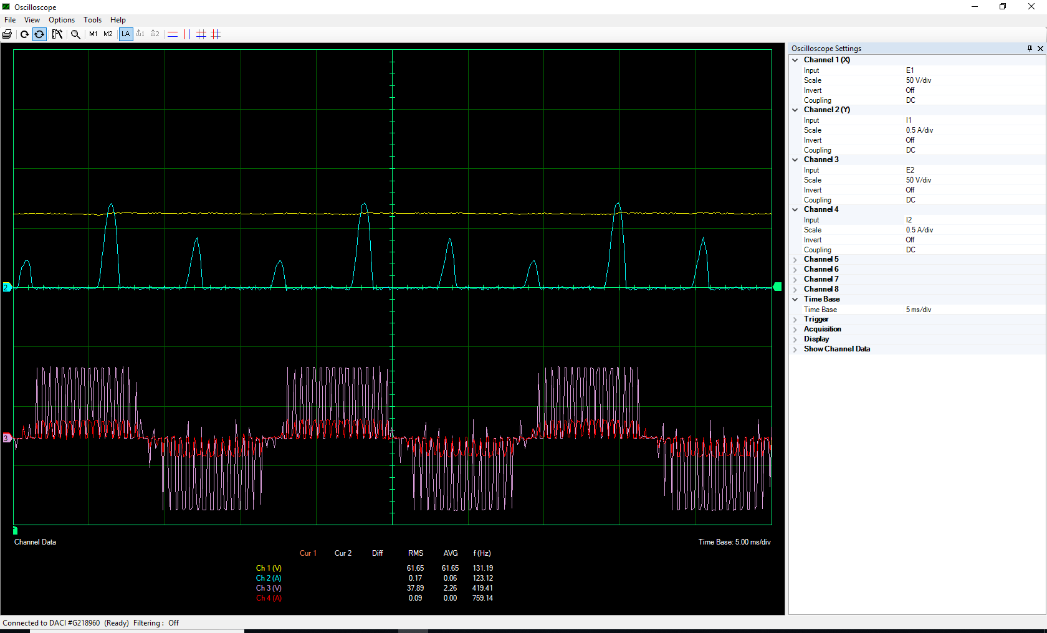

Figure 3:- The figure shows the waveforms of the input/output voltage and current.

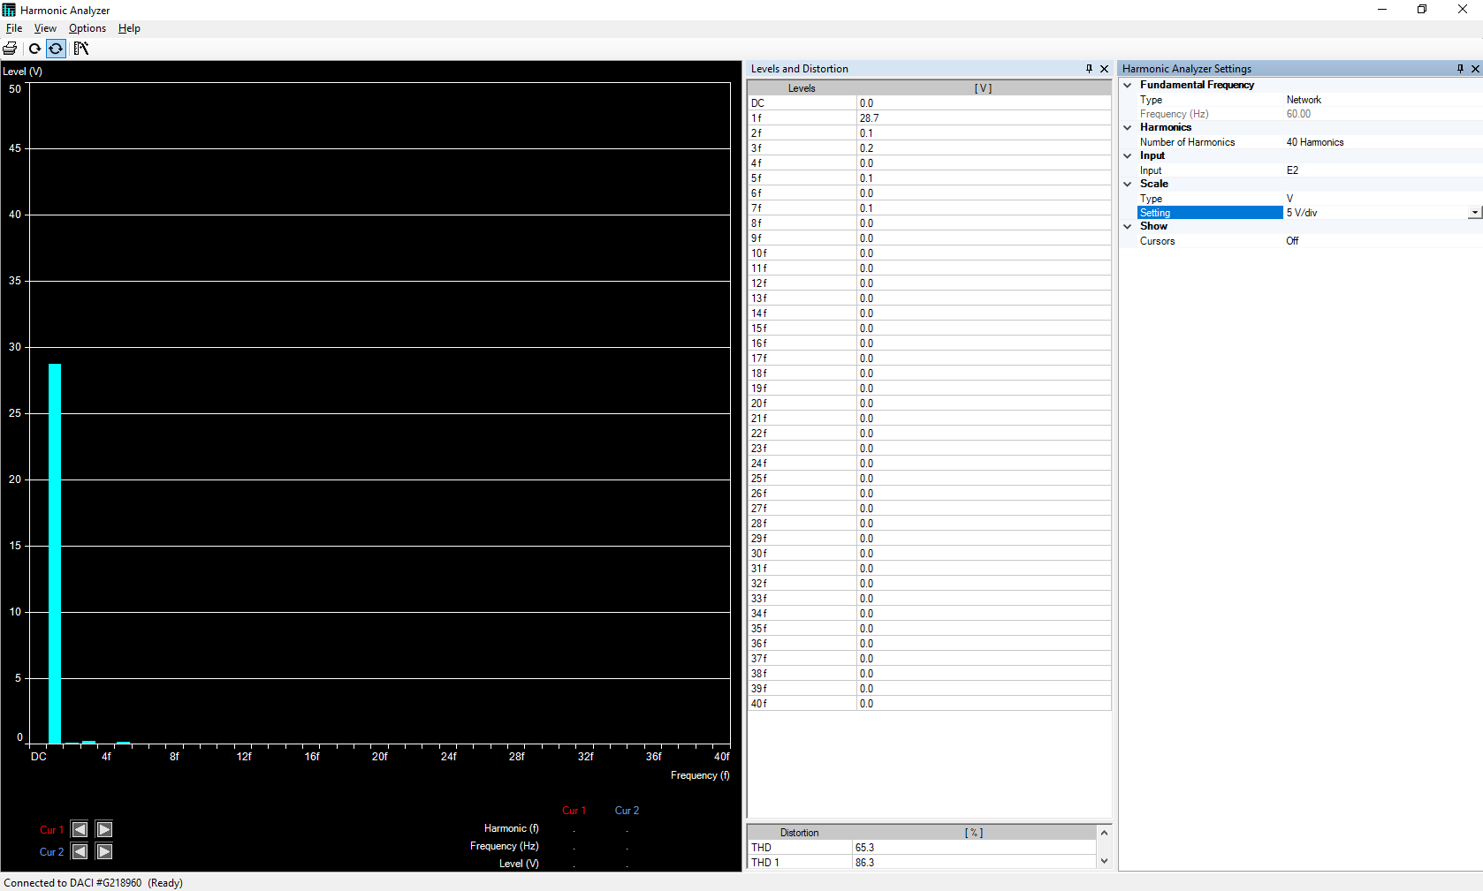

Figure 4:- The figure shows the harmonics of the output voltage

# 3 The 3phase 6-pulse inverter

The figure below shows the connection diagram of the 3phase 6-pulse inverter; the 3phase 6-pulse inverter was constructed using the labvolt IGBT chopper/inverter module.

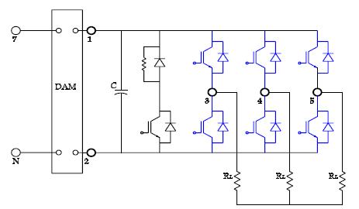

Figure 5:- The figure shows the connection diagram of the 3phase 6-pulse inverter

## 3.1 The Square-Wave Switching with 180o conduction

The switching pulses for the used IGBT switch are generated by the DC-AC converter firing angle controller for square-wave switching. This experiment was performed using a resistive load of 200ohms and a supply voltage of 60V. The data acquisition module (DAM) was used to observe and record; output voltage, output current, output power, and input power; these values are 27.92V, 0.141A, (3.88×3=11.64W), and 11.75W respectively. We observed and recorded the waveforms and harmonic spectrum of the output voltage (Vo) with THDV = 29.7%.

### 3.1.1 The waveforms and the harmonic spectrum of the output voltage

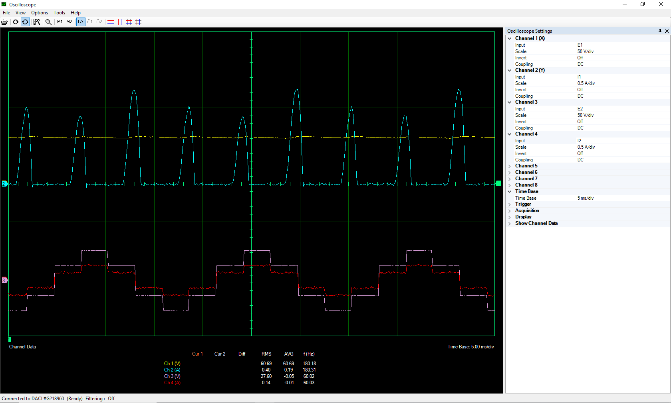

Figure 6:- The figure shows the waveforms of the input/output voltage and current.

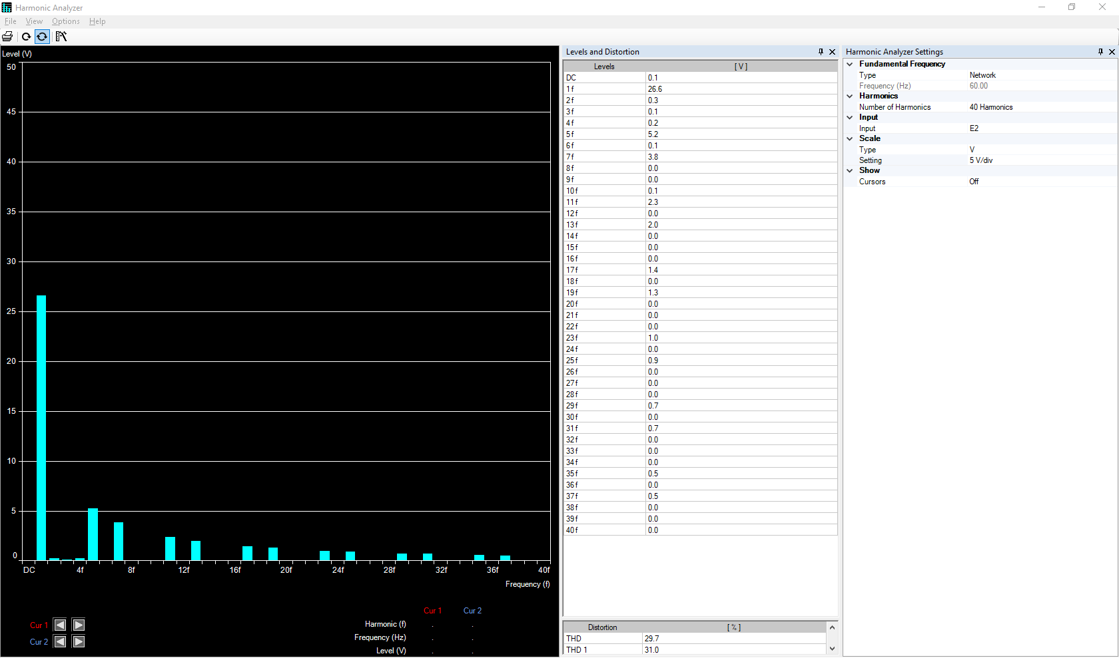

Figure 7:- The figure shows the harmonics of the output voltage

# 4 Conclusions

THD stands for Total Harmonic Distortion and it is defined as the ratio of the root mean square (RMS) voltage of all the harmonic frequencies (from the second harmonic) over the RMS voltage of the fundamental frequency. The equation is as follow:



For 50% duty cycle of square wave, the Fourier equation of it is as follow:



By putting it in the first equation and doing the Fourier analysis, it gives us the following value for the 50% duty cycle of square wave.



Therefore, the square wave has 48.3% THD which means the RMS of harmonics is about 48.3% RMS of the fundamental frequency. In our experiment for the single phase full-bridge inverter (square-wave switching) the THDv is 43.5%.

By PWM switching we can easier reach our desired output voltage and we have much control on it. In the single phase we have just 4 switching device that T1, T2 are switched together and T3, T4 are switched together in a complementary manner. In 3 phase square wave switching is almost the same but we use 6 switching elements. There are high harmonics in square wave in compare of PWM and the switching frequency is the same as the intended output frequency but in PWM it can be changed.

The efficiency of them are almost high for all of them but the PWM and 3phase are about 99% but for the single phase is 92%.

The output voltage in 3 phases is determined by potential differences between the output terminals of each leg. BY using 180-degree conduction, each switch is turned on 180. We can have two values for each pole so output voltage can have 8 states. Also the output voltage consist of 1,3,5, 7,... harmonics and according to the 120 degree phase shift between the waveforms, the harmonics orders which are multiple by 3 are cancelled.